Recursive Computational Compression Infrastructure and Admissibility-Preserving Recursive Abstraction Systems
Layer 2 Provisional Patent

Field of the Invention
The present disclosure relates generally to:
- recursive computational infrastructures,
- recursive abstraction systems,
- recursive compression architectures,
- lawful coarsening systems,
- recursive indexing systems,
- operational geometry systems,
- recursive traversal-preserving computation,
- scalable representation architectures,
- recursive world-model systems,
- hierarchical planning systems,
- graph abstraction systems,
- biological compression systems,
- and recursively organized lawful computational frameworks.
More specifically, the disclosure relates to:
- recursive admissibility-preserving compression,
- recursive traversal-preserving abstraction,
- operational continuity-preserving coarsening,
- recursive neighborhood-preserving reduction systems,
- recursively induced operational geometry,
- recursive transfer-preserving abstraction,
- recursive operational persistence,
- lawful recursive hierarchy formation,
- recursive geodesic-preserving compression,
- and recursively scalable lawful computational systems.
The disclosed systems may operate within:
- artificial intelligence systems,
- graph systems,
- manifold systems,
- world-model systems,
- robotics systems,
- biological systems,
- transfer-learning systems,
- simulation systems,
- reinforcement-learning systems,
- recursive planning systems,
- recursive search systems,
- distributed infrastructures,
- or recursively organized lawful computational substrates.

Background of the Invention
Conventional computational systems often scale poorly because abstraction and compression destroy meaningful operational structure.
In many existing systems:
- dimensionality reduction discards lawful traversal continuity,
- graph coarsening destroys meaningful reachability structure,
- latent compression collapses operational neighborhoods,
- hierarchical abstraction breaks lawful navigation continuity,
- and compressed representations fail to preserve operational compatibility.
Similarly, many contemporary representation-learning systems:
- compress representations according to statistical objectives,
- preserve local similarity without preserving lawful traversal continuity,
- or optimize embeddings while destroying operational reachability relationships.
As computational systems scale:
- independently reconstructable relationships increase rapidly,
- traversal spaces become combinatorially large,
- abstraction destroys lawful neighborhood continuity,
- transfer reliability decreases,
- and planning systems increasingly traverse operationally invalid state regions.
Existing abstraction systems frequently fail to preserve:
- lawful traversal pathways,
- operational geodesics,
- recursive neighborhood continuity,
- recursive reachability structure,
- admissible transformation continuity,
- or recursively preserved operational persistence.
Likewise, conventional compression systems often:
- reduce dimensionality without preserving operational continuity,
- compress states while destroying lawful traversal systems,
- or fail to preserve recursively admissible transformational structure during abstraction.
Accordingly, there exists a need for recursive computational infrastructures capable of:
- preserving lawful traversal continuity during abstraction,
- recursively preserving admissibility relationships,
- recursively organizing lawful neighborhood systems,
- preserving operational reachability during compression,
- and inducing scalable operational geometry across recursive abstraction scales.
There further exists a need for systems in which:
- recursively preserved operational structure remains computationally active during later abstraction stages,
- recursively admissible traversal constrains future computation,
- and recursively meaningful compression preserves lawful operational continuity during scaling.
Although certain examples discussed herein reference biological operational systems, the disclosed recursive computational compression infrastructures are not limited to biological domains and may operate over computational, symbolic, geometric, planning, graph-based, simulation, robotic, or recursively organized operational systems.

Core Architectural Thesis
The present disclosure introduces recursive computational compression infrastructures in which:
- lawful operational continuity governs recursive abstraction,
- recursively admissible traversal preserves meaningful computational structure,
- recursively organized neighborhoods induce scalable operational geometry,
- and recursively preserved admissibility constrains future abstraction and traversal.
Unlike conventional compression systems that:
- compress representations statistically,
- abstract states independently from lawful traversal continuity,
- or reduce dimensionality without preserving operational reachability,
the disclosed systems:
- preserve lawful traversal structure during abstraction,
- recursively preserve admissibility continuity,
- preserve operational geodesics across recursive scales,
- and induce scalable operational geometry from recursively admissible traversal systems.
In various embodiments:
- recursive compression operates over lawful transformational substrates,
- recursively meaningful abstraction preserves lawful traversal continuity,
- recursively induced geometry preserves operational reachability during scaling,
- and recursively preserved operational structure remains computationally active after abstraction.
In some embodiments:
- recursive abstraction preserves lawful computational continuity more effectively than arbitrary compression,
- recursively organized admissibility systems constrain future traversal,
- and recursively scalable computation emerges from lawful operational persistence across recursive abstraction levels.

Summary of the Invention
The present disclosure provides systems and methods for:
- recursive computational compression infrastructures,
- recursive traversal-preserving abstraction systems,
- admissibility-preserving coarsening architectures,
- recursive operational continuity preservation,
- recursive neighborhood-preserving compression,
- recursively induced operational geometry systems,
- recursive hierarchy-preserving computation,
- and recursively scalable lawful computational infrastructures.
In various embodiments:
- recursive abstraction preserves lawful traversal continuity,
- recursively admissible neighborhoods preserve operational reachability,
- recursively meaningful compression preserves lawful operational geometry,
- and recursively organized operational continuity constrains future computation.
In some embodiments:
- recursive coarsening preserves admissible traversal pathways,
- recursively induced geometry preserves operational geodesics during scaling,
- recursively organized hierarchy systems preserve lawful reachability continuity,
- and recursively preserved operational structure remains computationally active across abstraction levels.
Unlike conventional compression systems:
- dimensionality reduction alone does not define meaningful abstraction,
- latent similarity alone does not preserve operational compatibility,
- and lawful traversal continuity governs recursive compression quality.
In various embodiments:
- recursively preserved operational continuity reduces independently reconstructable relationships,
- recursively organized lawful abstraction improves transfer stability,
- recursively admissible traversal preserves meaningful planning continuity,
- and recursively scalable operational geometry supports large-scale lawful computation.
The disclosed systems may operate over:
- graph substrates,
- recursive relational substrates,
- manifold systems,
- symbolic systems,
- world-model systems,
- biological systems,
- recursive planning systems,
- latent traversal systems,
- or recursively organized operational state spaces.

Figures

Figure Descriptions

Figure 1 — Recursive Computational Compression Architecture
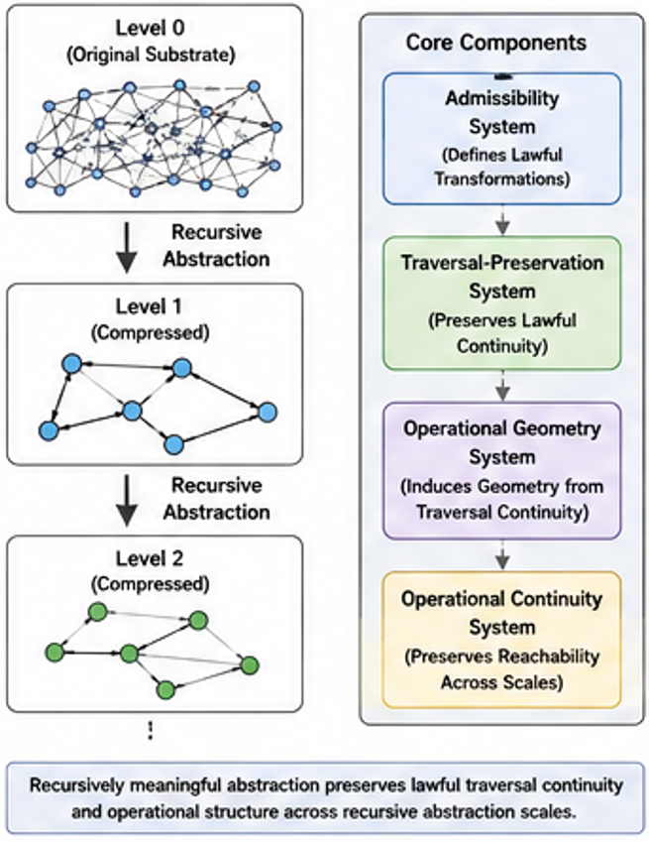
Figure 1 illustrates a recursive computational compression infrastructure in which:
- recursively admissible traversal systems preserve lawful operational continuity during abstraction,
- recursively organized neighborhoods preserve operational reachability,
- recursively meaningful compression preserves lawful traversal continuity,
- and recursively induced operational geometry preserves scalable computational organization.
In some embodiments:
- recursive abstraction preserves lawful traversal pathways more effectively than arbitrary compression,
- recursively preserved operational structure remains computationally active after abstraction,
- and recursively organized hierarchy systems preserve lawful continuity across recursive scales.

Figure 2 — Recursive Coarsening and Traversal Preservation
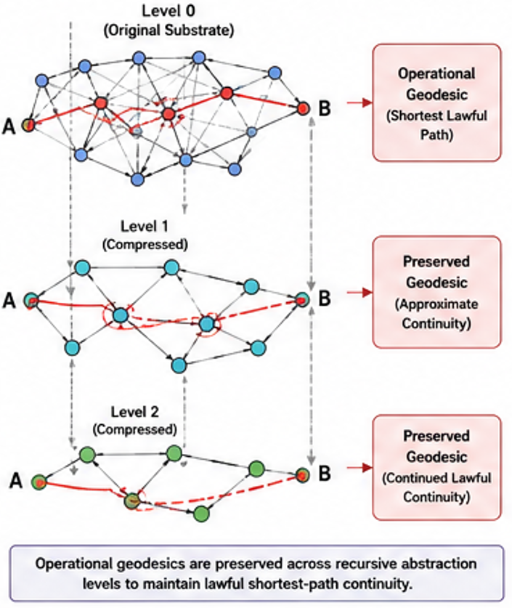
Figure 2 illustrates recursive coarsening systems preserving lawful traversal continuity across abstraction levels.
In some embodiments:
- recursively meaningful coarsening preserves operational geodesics,
- recursively admissible abstraction preserves lawful reachability,
- and recursively organized traversal systems preserve operational continuity during recursive scaling.
Figure 2 may illustrate:
- recursive abstraction layers,
- lawful traversal pathways,
- operational geodesics,
- recursively preserved neighborhoods,
- recursive hierarchy systems,
- or recursively admissible compression structure.

Figure 3 — Recursive Reachability Preservation System
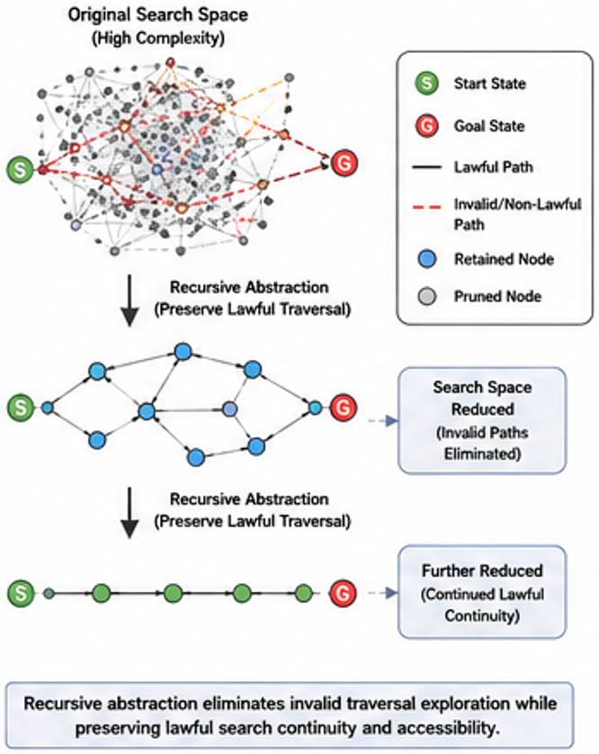
Figure 3 illustrates recursive preservation of lawful reachability during recursive abstraction and compression.
In some embodiments:
- recursively admissible traversal preserves lawful operational accessibility,
- recursively organized abstraction systems preserve recursive navigation continuity,
- and recursively induced operational geometry preserves lawful traversal coherence during scaling.
Figure 3 may further illustrate:
- reachability continuity,
- recursive navigation systems,
- operational continuity preservation,
- recursive path systems,
- or recursively admissible traversal continuity.

Figure 4 — Multi-Scale Recursive Planning Architecture
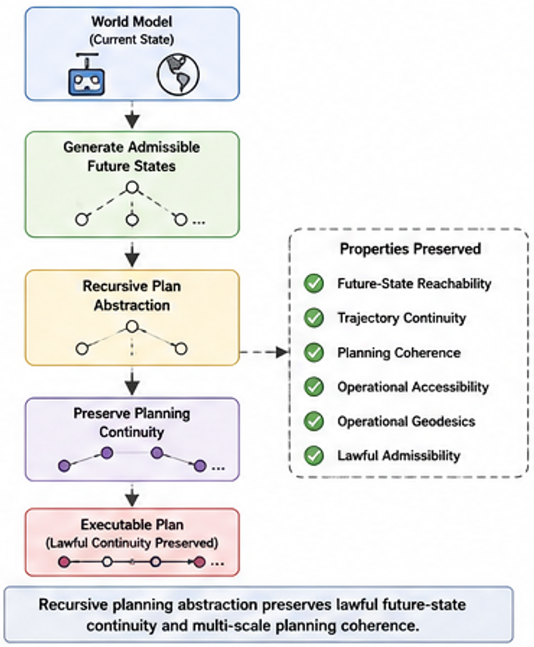
Figure 4 illustrates recursive planning systems operating over recursively compressed lawful traversal structures.
In some embodiments:
- recursively admissible traversal constrains planning trajectories,
- recursively meaningful abstraction preserves lawful navigation continuity,
- and recursively induced operational geometry preserves multi-scale planning coherence.
Figure 4 may illustrate:
- recursive planning hierarchies,
- abstraction-preserving navigation,
- recursively admissible trajectory systems,
- recursive future-state planning,
- or recursively organized operational geometry.

Figure 5 — Recursive Symmetry Compression System
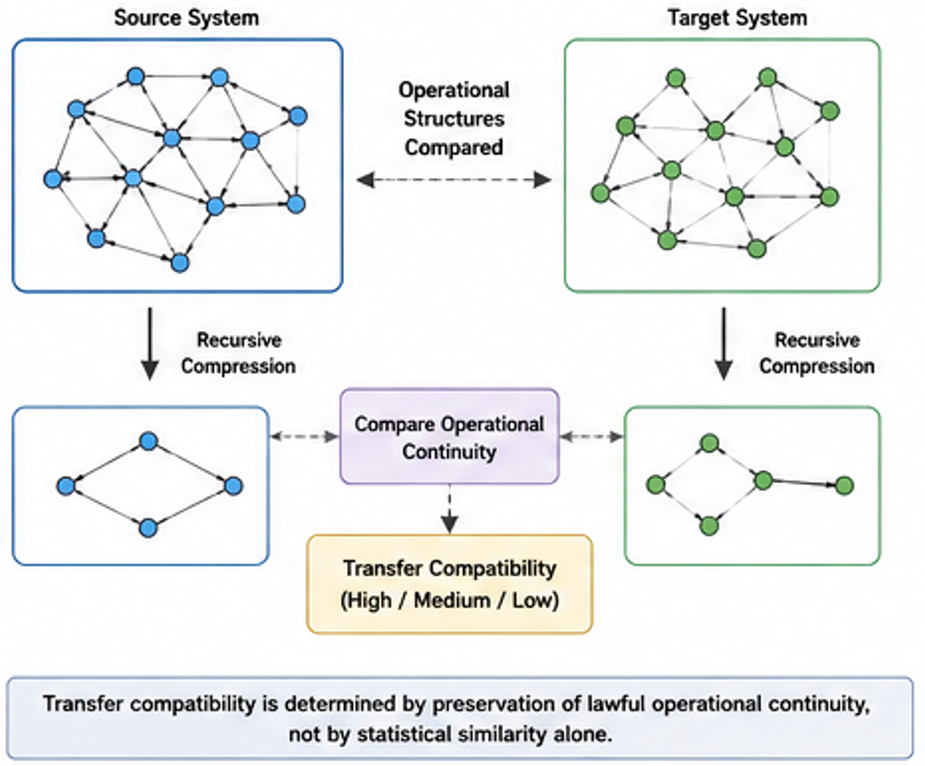
Figure 5 illustrates recursive symmetry-preserving compression systems.
In some embodiments:
- recursively equivalent traversal systems reduce independently reconstructable relationships,
- recursively admissible symmetry structure preserves lawful operational continuity,
- and recursively organized equivalence systems preserve lawful compression continuity during scaling.
Figure 5 may illustrate:
- recursive equivalence systems,
- recursive symmetry groups,
- lawful transformational redundancy reduction,
- recursive traversal-preserving compression,
- or recursively admissible abstraction continuity.

Figure 6 — Recursive Generative Compression System
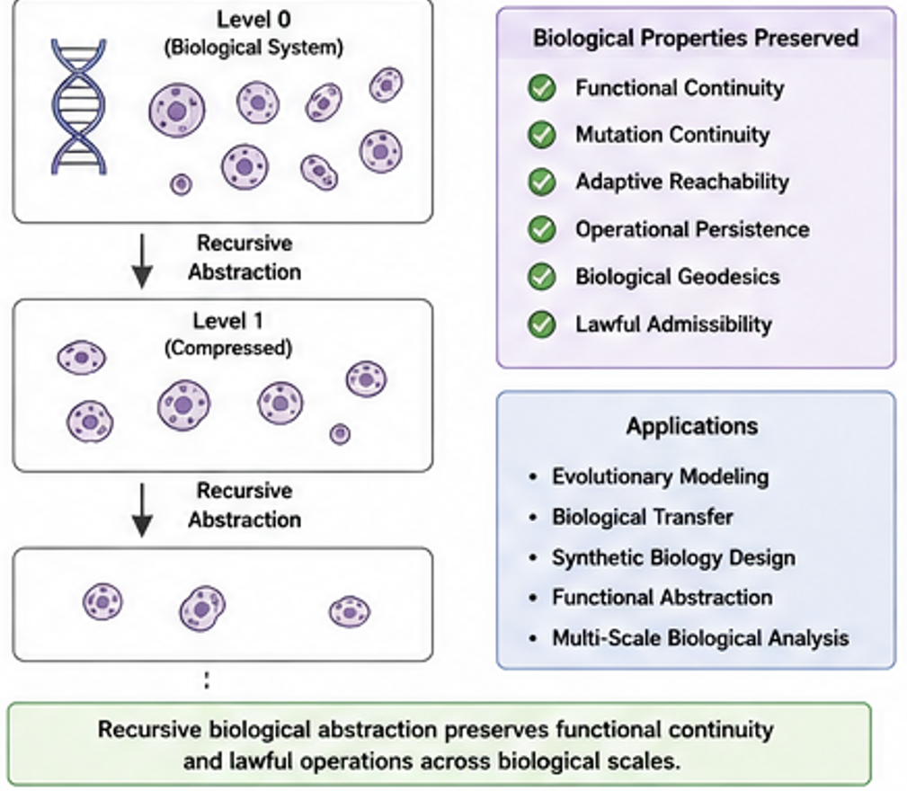
Figure 6 illustrates recursively generated lawful compression systems operating over recursively admissible transformational substrates.
In some embodiments:
- recursively admissible neighborhoods recursively generate higher-order lawful abstraction systems,
- recursively preserved operational continuity recursively constrains future compression structure,
- and recursively induced geometry preserves lawful traversal continuity during recursive scaling.
Figure 6 may illustrate:
- recursive abstraction generation,
- recursive lawful hierarchy formation,
- recursively admissible neighborhood induction,
- recursive compression propagation,
- or recursively organized operational continuity systems.

Recursive Computational Compression Framework
In some embodiments:
- recursive computational compression proceeds according to:
$C^{\left(k+1\right)}=A\left(C^{\left(k\right)},T^{\left(k\right)},A^{\left(k\right)},S\right)$
where:
- $C^{\left(k\right)}$ represents recursive compression structure,
- $T^{\left(k\right)}$ represents traversal continuity,
- $A^{\left(k\right)}$ represents admissibility structure,
- $S$ represents substrate structure,
- and $A$ represents a recursive abstraction operator.
In some embodiments:
- recursively meaningful abstraction preserves lawful traversal continuity,
- recursively admissible traversal systems preserve operational reachability during scaling,
- and recursively induced geometry preserves lawful operational continuity across recursive abstraction levels.

Recursive Operational Continuity
In some embodiments:
- recursively preserved operational structure remains computationally active after abstraction and compression.
Recursive operational continuity may preserve:
- lawful traversal pathways,
- recursive operational reachability,
- recursive neighborhood continuity,
- operational geodesics,
- recursive hierarchy structure,
- recursive planning continuity,
- or recursively admissible transformational persistence.
In some embodiments:
- recursively organized abstraction systems preserve lawful operational continuity during scaling,
- recursively admissible traversal systems constrain future compression organization,
- and recursively induced geometry preserves meaningful operational continuity across recursive abstraction scales.

Core Definitions

Recursive Computational Compression
Recursive computational compression refers to recursively organized abstraction preserving lawful operational continuity across recursive scales.
In some embodiments:
- recursively meaningful abstraction preserves lawful traversal structure,
- recursively admissible compression preserves operational reachability,
- and recursively preserved operational continuity remains computationally active after abstraction.
Unlike conventional dimensionality reduction systems:
- recursive computational compression preserves lawful transformational continuity rather than statistical similarity alone.

Recursive Abstraction
Recursive abstraction refers to recursively organized compression preserving lawful operational structure across abstraction levels.
Recursive abstraction may preserve:
- recursive traversal continuity,
- recursive neighborhood organization,
- operational geodesics,
- recursive reachability,
- recursive planning continuity,
- or recursively admissible transformational structure.
In some embodiments:
- recursively meaningful abstraction preserves lawful operational continuity more effectively than arbitrary compression,
- recursively organized abstraction systems preserve admissible traversal systems,
- and recursively induced geometry preserves lawful continuity during scaling.

Recursive Coarsening
Recursive coarsening refers to recursively organizing lower-level structures into higher-order lawful abstraction systems while preserving operational continuity.
Recursive coarsening may preserve:
- lawful traversal pathways,
- recursive operational reachability,
- recursive hierarchy continuity,
- recursive neighborhood structure,
- operational geodesics,
- or recursively admissible traversal continuity.
In some embodiments:
- recursively meaningful coarsening preserves lawful traversal structure,
- recursively preserved operational continuity constrains future abstraction organization,
- and recursively organized coarsening systems preserve lawful continuity across recursive scales.

Traversal-Preserving Compression
Traversal-preserving compression refers to abstraction preserving lawful traversal continuity during compression and scaling.
Traversal-preserving compression may preserve:
- recursive path fidelity,
- recursive reachability,
- lawful navigation continuity,
- recursive planning continuity,
- operational geodesics,
- or recursively admissible traversal structure.
In some embodiments:
- recursively admissible traversal systems remain operationally active after abstraction,
- recursively meaningful compression preserves lawful operational continuity,
- and recursively induced geometry preserves meaningful traversal structure during scaling.

Recursive Reachability Preservation
Recursive reachability preservation refers to preserving lawful accessibility relationships across recursive abstraction levels.
In some embodiments:
- recursively organized abstraction systems preserve lawful operational accessibility,
- recursively admissible traversal preserves recursive navigation continuity,
- and recursively induced geometry preserves lawful future-state reachability during scaling.
Recursive reachability preservation may preserve:
- lawful navigation continuity,
- recursive traversal coherence,
- recursive planning continuity,
- recursive operational accessibility,
- or recursively admissible path systems.

Operational Geodesic
An operational geodesic comprises a lawful traversal pathway preserving admissible operational continuity across recursively organized abstraction systems.
In some embodiments:
- operational geodesics preserve lawful traversal continuity during abstraction,
- recursively admissible traversal preserves geodesic continuity,
- and recursively induced geometry preserves lawful navigation structure across recursive scales.

Recursive Hierarchy Preservation
Recursive hierarchy preservation refers to preserving lawful operational continuity across recursively organized abstraction hierarchies.
Recursive hierarchy preservation may preserve:
- recursive neighborhood continuity,
- recursive traversal systems,
- recursive planning structure,
- recursive operational persistence,
- recursive abstraction continuity,
- or recursively admissible transformational organization.
In some embodiments:
- recursively preserved operational structure remains active across hierarchy levels,
- recursively meaningful abstraction preserves lawful hierarchy continuity,
- and recursively induced geometry preserves lawful operational organization during scaling.

Recursive Operational Continuity
Recursive operational continuity refers to preservation of lawful operational structure across recursive abstraction and compression stages.
In some embodiments:
- recursively preserved operational structure constrains future computation,
- recursively organized abstraction systems preserve lawful traversal continuity,
- and recursively admissible transformational continuity remains operationally active after compression.
Recursive operational continuity may preserve:
- recursive traversal structure,
- recursive neighborhood organization,
- recursive planning continuity,
- recursive reachability,
- operational geodesics,
- or recursively admissible transformational persistence.

Recursive Symmetry Compression
Recursive symmetry compression refers to compression using recursively preserved equivalence and symmetry relationships.
Recursive symmetry compression may preserve:
- recursively equivalent traversal systems,
- lawful transformational redundancy reduction,
- recursive equivalence continuity,
- recursive operational structure,
- recursive neighborhood organization,
- or recursively admissible abstraction continuity.
In some embodiments:
- recursively equivalent transformations reduce independently reconstructable relationships,
- recursively preserved symmetry systems improve compression continuity,
- and recursively induced operational geometry preserves lawful traversal continuity during scaling.

Recursive Generative Compression
Recursive generative compression refers to recursively generating higher-order lawful abstraction systems from recursively admissible organizational structure.
In some embodiments:
- recursively admissible neighborhoods recursively generate higher-order lawful abstraction systems,
- recursively preserved operational continuity recursively constrains future compression organization,
- and recursively organized lawful continuity recursively induces scalable operational geometry.
Recursive generative compression may preserve:
- recursive abstraction continuity,
- recursive traversal structure,
- recursive hierarchy formation,
- recursive operational persistence,
- or recursively admissible transformational organization.

Recursive Planning Compression
Recursive planning compression refers to preserving lawful planning continuity during recursive abstraction and coarsening.
Recursive planning compression may preserve:
- lawful navigation continuity,
- recursive future-state reachability,
- recursive trajectory continuity,
- recursive operational planning structure,
- operational geodesics,
- or recursively admissible planning systems.
In some embodiments:
- recursively admissible traversal constrains planning trajectories,
- recursively meaningful abstraction preserves lawful planning continuity,
- and recursively induced geometry preserves meaningful multi-scale navigation systems.

Recursive Search Reduction
Recursive search reduction refers to reducing computational search complexity while preserving lawful operational continuity.
Recursive search reduction may preserve:
- lawful traversal continuity,
- recursive operational reachability,
- recursive planning continuity,
- recursive navigation structure,
- recursive abstraction continuity,
- or recursively admissible transformational systems.
In some embodiments:
- recursively organized abstraction systems reduce invalid traversal exploration,
- recursively meaningful compression preserves lawful search continuity,
- and recursively induced geometry preserves meaningful operational accessibility during scaling.

Recursive Transfer-Preserving Compression
Recursive transfer-preserving compression refers to preserving lawful operational continuity during abstraction while maintaining transfer compatibility across systems.
Recursive transfer-preserving compression may preserve:
- recursive traversal continuity,
- recursive neighborhood compatibility,
- recursive operational geometry,
- recursive reachability,
- recursive planning continuity,
- or recursively admissible transformational continuity.
In some embodiments:
- recursively preserved operational continuity improves transfer stability,
- recursively admissible abstraction preserves lawful compatibility,
- and recursively organized operational geometry constrains meaningful transfer pathways.

Recursive Biological Compression
Recursive biological compression refers to preserving lawful biological operational continuity during recursive abstraction and coarsening.
Recursive biological compression may preserve:
- recursive biological traversal,
- lawful mutation continuity,
- recursive biological reachability,
- recursive functional continuity,
- recursive biological neighborhood organization,
- or recursively admissible biological pathways.
In some embodiments:
- recursively meaningful biological abstraction preserves functional continuity,
- recursively preserved biological operational structure remains active during abstraction,
- and recursively induced biological geometry preserves lawful biological continuity during scaling.

Recursive Compression Geometry
Recursive compression geometry refers to operational geometry induced from recursively admissible abstraction continuity.
Recursive compression geometry may preserve:
- lawful abstraction continuity,
- recursive operational geodesics,
- recursive reachability structure,
- recursive hierarchy continuity,
- recursive traversal organization,
- or recursively admissible compression structure.
In some embodiments:
- recursively meaningful abstraction induces stable operational geometry,
- recursively organized compression systems preserve lawful continuity,
- and recursively preserved operational structure governs scalable lawful computational organization.

Transformational Compression Systems

Transformational Compression Systems
The present disclosure introduces transformational compression systems in which:
- recursive abstraction preserves lawful operational continuity,
- recursively admissible traversal constrains compression organization,
- and recursively induced operational geometry preserves meaningful computational structure during scaling.
Recursive operational continuity preservation is substrate-independent and may emerge across substantially different lawful transformational systems. Biological embodiments represent one example of recursively admissible operational organization and do not limit the scope of the disclosed compression infrastructures.
Unlike conventional compression systems that:
- compress statistical similarity,
- reduce dimensionality independently from operational continuity,
- or abstract representations without preserving lawful traversal structure,
the disclosed systems:
- preserve admissible transformational continuity during compression,
- recursively preserve lawful operational structure,
- and maintain meaningful traversal continuity across recursive abstraction scales.
In some embodiments:
- recursively meaningful abstraction preserves lawful computational organization more effectively than arbitrary dimensionality reduction,
- recursively organized operational continuity constrains future abstraction pathways,
- and recursively admissible traversal systems preserve scalable lawful computation.

Substrate-Dependent Compressibility
In some embodiments:
- compressibility depends on transformational substrate structure.
Different substrates naturally support different:
- recursive abstraction systems,
- lawful traversal organizations,
- recursive equivalence structures,
- recursive hierarchy systems,
- recursive operational continuity relationships,
- or recursively admissible compression geometries.
In some embodiments:
- bounded lawful substrates reduce independently reconstructable operational relationships,
- recursively admissible traversal systems preserve lawful compression continuity,
- and recursively induced geometry preserves scalable operational organization during abstraction.
Examples may include:
- sphere-based compression substrates,
- graph-based compression substrates,
- recursive relational compression systems,
- symbolic abstraction substrates,
- manifold abstraction systems,
- or recursively admissible operational substrates.

Recursive Operational Persistence
In some embodiments:
- recursively preserved operational structure remains computationally active after abstraction and compression.
Recursive operational persistence may preserve:
- lawful traversal continuity,
- recursive reachability,
- recursive neighborhood organization,
- recursive planning continuity,
- recursive abstraction structure,
- operational geodesics,
- or recursively admissible transformational persistence.
In some embodiments:
- recursively meaningful abstraction preserves operational continuity during scaling,
- recursively organized compression systems preserve lawful traversal structure,
- and recursively induced geometry preserves meaningful operational continuity across recursive abstraction levels.
Unlike conventional abstraction systems:
- operational structure is not discarded after compression.

Recursive Coarsening Systems
In some embodiments:
- recursive coarsening preserves lawful traversal continuity during abstraction.
Recursive coarsening systems may preserve:
- recursive path fidelity,
- recursive operational reachability,
- recursive hierarchy continuity,
- recursive neighborhood structure,
- operational geodesics,
- or recursively admissible traversal continuity.
In some embodiments:
- recursively meaningful coarsening preserves lawful navigation continuity,
- recursively admissible abstraction preserves lawful reachability,
- and recursively organized hierarchy systems preserve lawful computational continuity during scaling.
In some embodiments:
- recursively meaningful coarsening preserves lawful traversal more effectively than arbitrary coarsening systems.

Recursive Hierarchy Formation
In some embodiments:
- recursively admissible neighborhoods recursively induce higher-order lawful abstraction systems.
Recursive hierarchy formation may preserve:
- recursive neighborhood continuity,
- recursive operational structure,
- recursive planning continuity,
- recursive traversal systems,
- recursive abstraction continuity,
- or recursively admissible transformational organization.
In some embodiments:
- recursively preserved operational continuity constrains future hierarchy organization,
- recursively meaningful abstraction preserves lawful multi-scale continuity,
- and recursively induced geometry preserves meaningful recursive hierarchy structure.

Recursive Traversal Continuity
In some embodiments:
- recursive abstraction preserves lawful traversal continuity across recursive scales.
Recursive traversal continuity may preserve:
- recursive path fidelity,
- recursive navigation continuity,
- recursive operational accessibility,
- operational geodesics,
- recursive planning continuity,
- or recursively admissible traversal systems.
In some embodiments:
- recursively organized abstraction systems preserve lawful navigation structure,
- recursively admissible traversal systems remain operationally active after abstraction,
- and recursively induced geometry preserves lawful traversal continuity during recursive scaling.

Operational Geodesic Preservation
In some embodiments:
- recursively meaningful compression preserves operational geodesics.
Operational geodesic preservation may preserve:
- lawful shortest-path continuity,
- recursive reachability,
- recursive navigation coherence,
- recursive planning continuity,
- recursive abstraction continuity,
- or recursively admissible traversal organization.
In some embodiments:
- recursively preserved operational geometry constrains future traversal pathways,
- recursively meaningful abstraction preserves lawful navigation structure,
- and recursively induced operational continuity preserves meaningful multi-scale reachability.

Recursive Equivalence Compression
In some embodiments:
- recursive compression preserves lawful equivalence structure during abstraction.
Recursive equivalence compression may preserve:
- recursively equivalent traversal systems,
- recursive symmetry structure,
- recursive neighborhood continuity,
- recursive operational persistence,
- recursive abstraction coherence,
- or recursively admissible transformational equivalence.
In some embodiments:
- recursively equivalent transformations reduce independently reconstructable relationships,
- recursively organized equivalence systems preserve lawful compression continuity,
- and recursively induced operational geometry preserves meaningful abstraction structure during scaling.

Recursive Generative Abstraction
In some embodiments:
- recursively admissible neighborhoods recursively generate higher-order lawful abstraction systems.
Recursive generative abstraction may preserve:
- recursive hierarchy continuity,
- recursive traversal organization,
- recursive abstraction persistence,
- recursive operational structure,
- recursive neighborhood continuity,
- or recursively admissible transformational organization.
In some embodiments:
- recursively preserved operational continuity recursively constrains future abstraction pathways,
- recursively meaningful compression preserves lawful recursive organization,
- and recursively induced geometry preserves scalable lawful abstraction continuity.

Recursive Search Reduction
In some embodiments:
- recursive abstraction reduces computational search complexity while preserving lawful operational continuity.
Recursive search reduction may preserve:
- lawful traversal continuity,
- recursive planning continuity,
- recursive operational reachability,
- recursive navigation structure,
- recursive abstraction coherence,
- or recursively admissible traversal organization.
In some embodiments:
- recursively organized abstraction systems reduce invalid traversal exploration,
- recursively meaningful compression preserves lawful search continuity,
- and recursively induced geometry preserves meaningful operational accessibility during scaling.

Recursive Planning Compression
In some embodiments:
- recursive abstraction preserves lawful planning continuity during scaling.
Recursive planning compression may preserve:
- recursive trajectory continuity,
- recursive future-state reachability,
- recursive navigation systems,
- recursive abstraction continuity,
- operational geodesics,
- or recursively admissible planning systems.
In some embodiments:
- recursively admissible traversal constrains planning trajectories,
- recursively meaningful abstraction preserves lawful planning continuity,
- and recursively induced operational geometry preserves meaningful multi-scale navigation continuity.

Recursive World-Model Compression
In some embodiments:
- recursive world-model systems preserve lawful operational continuity during recursive abstraction.
Recursive world-model compression may preserve:
- lawful future-state reachability,
- recursive traversal continuity,
- recursive planning structure,
- recursive abstraction continuity,
- operational geodesics,
- or recursively admissible future-state organization.
In some embodiments:
- recursively preserved operational continuity constrains future-state planning,
- recursively admissible traversal systems preserve lawful world-model continuity,
- and recursively induced geometry preserves meaningful planning organization during scaling.

Recursive Biological Compression
In some embodiments:
- recursive biological abstraction preserves lawful biological operational continuity during scaling.
Recursive biological compression may preserve:
- recursive biological traversal,
- lawful mutation continuity,
- recursive functional continuity,
- recursive biological neighborhood structure,
- recursive operational persistence,
- or recursively admissible biological pathways.
In some embodiments:
- recursively meaningful biological abstraction preserves functional continuity,
- recursively preserved biological operational structure remains active during abstraction,
- and recursively induced biological geometry preserves lawful biological continuity across recursive abstraction scales.

Recursive AI Compression, Planning, and World-Model Systems

Recursive AI Compression Systems
The present disclosure introduces recursive AI compression systems in which:
- recursively meaningful abstraction preserves lawful operational continuity,
- recursively admissible traversal constrains compression organization,
- and recursively induced operational geometry preserves scalable lawful computation during abstraction and scaling.
Unlike conventional artificial intelligence systems that:
- compress latent representations statistically,
- abstract planning systems independently from lawful traversal continuity,
- or reduce computational structure without preserving operational reachability,
the disclosed systems:
- preserve lawful traversal continuity during recursive abstraction,
- recursively preserve admissible operational structure,
- and maintain meaningful operational continuity across recursive computational scales.
In some embodiments:
- recursively meaningful compression preserves lawful AI traversal continuity more effectively than arbitrary abstraction,
- recursively admissible traversal constrains latent compression organization,
- and recursively organized operational geometry preserves meaningful computational continuity during scaling.

Recursive World-Model Compression Systems
In some embodiments:
- recursive world-model systems preserve lawful future-state continuity during recursive abstraction.
Recursive world-model compression may preserve:
- lawful future-state reachability,
- recursive trajectory continuity,
- recursive planning coherence,
- recursive operational persistence,
- operational geodesics,
- or recursively admissible future-state organization.
In some embodiments:
- recursively preserved operational continuity constrains future-state planning,
- recursively admissible traversal systems preserve lawful predictive continuity,
- and recursively induced geometry preserves meaningful world-model organization during scaling.
Unlike unconstrained predictive abstraction systems:
- recursively organized world models preserve lawful traversal continuity during future-state generation.

Recursive Planning Abstraction Systems
In some embodiments:
- recursive abstraction preserves lawful planning continuity across abstraction scales.
Recursive planning abstraction may preserve:
- recursive navigation continuity,
- recursive trajectory reachability,
- recursive planning structure,
- recursive operational accessibility,
- operational geodesics,
- or recursively admissible planning systems.
In some embodiments:
- recursively admissible traversal constrains planning trajectories,
- recursively meaningful abstraction preserves lawful navigation continuity,
- and recursively induced operational geometry preserves meaningful multi-scale planning coherence.
Recursive planning abstraction may support:
- autonomous navigation,
- robotic planning,
- recursive simulation systems,
- recursive decision architectures,
- recursive future-state planning,
- or recursively constrained traversal systems.

Recursive Navigation Systems
In some embodiments:
- recursive navigation systems preserve lawful traversal continuity during scaling and abstraction.
Recursive navigation systems may preserve:
- recursive path fidelity,
- recursive operational reachability,
- lawful navigation continuity,
- recursive traversal coherence,
- operational geodesics,
- or recursively admissible trajectory systems.
In some embodiments:
- recursively meaningful abstraction preserves lawful navigation continuity,
- recursively organized traversal systems preserve meaningful operational accessibility,
- and recursively induced geometry preserves scalable lawful navigation structure.

Recursive Search Compression Systems
In some embodiments:
- recursive compression reduces search complexity while preserving lawful traversal continuity.
Recursive search compression may preserve:
- recursive planning continuity,
- recursive operational reachability,
- lawful traversal systems,
- recursive abstraction continuity,
- recursive navigation structure,
- or recursively admissible search organization.
In some embodiments:
- recursively organized abstraction systems reduce invalid traversal exploration,
- recursively meaningful compression preserves lawful search continuity,
- and recursively induced operational geometry preserves meaningful operational accessibility during scaling.
Unlike arbitrary search-space reduction systems:
- recursively meaningful abstraction preserves lawful operational continuity during search reduction.

Recursive Operational Memory Systems
In some embodiments:
- recursively preserved operational structure remains computationally active after abstraction and compression.
Recursive operational memory systems may preserve:
- recursive traversal continuity,
- recursive operational persistence,
- recursive hierarchy continuity,
- recursive planning structure,
- recursive navigation continuity,
- or recursively admissible transformational organization.
In some embodiments:
- recursively meaningful abstraction preserves operational continuity during later computational stages,
- recursively organized abstraction systems preserve lawful operational persistence,
- and recursively induced geometry preserves meaningful computational continuity across recursive scales.

Recursive Transfer Compression Systems
In some embodiments:
- recursive compression preserves lawful transfer compatibility across abstraction scales.
Recursive transfer compression may preserve:
- recursive traversal continuity,
- recursive neighborhood compatibility,
- recursive operational geometry,
- recursive planning continuity,
- recursive abstraction coherence,
- or recursively admissible transformational continuity.
In some embodiments:
- recursively preserved operational continuity improves transfer stability,
- recursively admissible abstraction preserves lawful compatibility,
- and recursively induced geometry preserves meaningful transfer continuity during scaling.
In some embodiments:
- statistically similar systems may remain operationally incompatible if lawful traversal continuity is not preserved during abstraction.

Recursive Multi-Scale Computation
In some embodiments:
- recursively organized abstraction systems preserve lawful operational continuity across recursive computational scales.
Recursive multi-scale computation may preserve:
- local lawful traversal continuity,
- global operational reachability,
- recursive hierarchy coherence,
- recursive planning continuity,
- recursive abstraction persistence,
- or recursively admissible operational organization.
In some embodiments:
- recursively admissible neighborhoods recursively induce higher-order lawful abstraction systems,
- recursively preserved operational continuity remains active during later recursive stages,
- and recursively induced geometry preserves scalable lawful computational continuity during abstraction and compression.

Recursive Latent Compression Systems
In some embodiments:
- latent-space abstraction preserves lawful operational continuity during recursive compression.
Recursive latent compression may preserve:
- recursive traversal continuity,
- recursive operational geodesics,
- recursive neighborhood organization,
- recursive abstraction coherence,
- recursive planning continuity,
- or recursively admissible latent organization.
In some embodiments:
- recursively meaningful abstraction preserves lawful latent continuity,
- recursively admissible traversal constrains latent compression structure,
- and recursively induced geometry preserves meaningful latent operational continuity during scaling.

Recursive Continuity-Preserving Inference
In some embodiments:
- inference systems preserve lawful operational continuity during recursive abstraction.
Recursive inference systems may preserve:
- recursive traversal continuity,
- recursive operational accessibility,
- recursive hierarchy continuity,
- recursive planning structure,
- recursive abstraction continuity,
- or recursively admissible inferential organization.
In some embodiments:
- recursively preserved operational continuity constrains inferential trajectories,
- recursively meaningful abstraction preserves lawful inference continuity,
- and recursively induced geometry preserves meaningful operational continuity during recursive scaling.

Recursive Operational Stability
In some embodiments:
- computational stability emerges from recursively preserved operational continuity rather than statistical compression alone.
Recursive operational stability may preserve:
- lawful traversal continuity,
- recursive planning continuity,
- recursive operational reachability,
- recursive hierarchy coherence,
- recursive abstraction continuity,
- or recursively admissible transformational persistence.
In some embodiments:
- recursively preserved operational continuity constrains future computational organization,
- recursively meaningful abstraction preserves lawful operational stability,
- and recursively induced geometry preserves meaningful operational continuity across recursive abstraction scales.

Operational Compression Metrics
In some embodiments:
- recursive compression systems are evaluated using operational continuity metrics rather than dimensionality-reduction metrics alone.
Operational compression metrics may include:
- recursive path-fidelity retention,
- recursive reachability preservation,
- operational geodesic continuity,
- recursive hierarchy consistency,
- recursive traversal coherence,
- recursive planning continuity,
- recursive abstraction continuity,
- recursive transfer compatibility,
- bottleneck preservation,
- geodesic distortion,
- recursive operational persistence,
- recursive neighborhood continuity,
- or recursively admissible traversal-preservation metrics.
In some embodiments:
- compression quality depends on preservation of lawful operational continuity across recursive abstraction scales.

Operational Embodiments and Example Algorithms

Operational Embodiments
The following embodiments are illustrative examples only. The disclosed recursive computational compression infrastructures are not limited to biological systems and may operate across substantially different adaptive, computational, operational, or representational domains.

Embodiment 1 — Recursive Traversal-Preserving Compression System
In some embodiments:
- recursively meaningful abstraction preserves lawful traversal continuity during compression,
- recursively admissible traversal systems remain operationally active after abstraction,
- and recursively induced geometry preserves lawful operational continuity across recursive scales.
In some embodiments:
- recursive traversal-preserving compression improves operational reachability retention during scaling,
- recursively organized abstraction systems preserve lawful navigation continuity,
- and recursively meaningful coarsening preserves lawful traversal structure more effectively than arbitrary dimensionality reduction.

Embodiment 2 — Recursive Operational Geodesic Preservation System
In some embodiments:
- recursively meaningful abstraction preserves operational geodesics during recursive compression.
In some embodiments:
- recursively admissible traversal preserves lawful shortest-path continuity,
- recursively preserved operational continuity constrains future traversal pathways,
- and recursively induced geometry preserves meaningful navigation coherence across abstraction scales.
In some embodiments:
- operational geodesic preservation improves planning continuity during recursive abstraction.

Embodiment 3 — Recursive Search Reduction System
In some embodiments:
- recursively organized abstraction systems reduce computational search complexity while preserving lawful operational continuity.
In some embodiments:
- recursively meaningful compression reduces invalid traversal exploration,
- recursively admissible traversal systems preserve lawful search continuity,
- and recursively induced geometry preserves meaningful operational accessibility during scaling.
In some embodiments:
- recursive search reduction improves scalable planning and inference continuity.

Embodiment 4 — Recursive Planning Compression Architecture
In some embodiments:
- recursive abstraction preserves lawful planning continuity during scaling.
In some embodiments:
- recursively admissible traversal constrains planning trajectories,
- recursively meaningful abstraction preserves lawful navigation continuity,
- and recursively induced geometry preserves meaningful multi-scale planning coherence.
In some embodiments:
- recursive planning compression supports recursive world-model traversal and future-state prediction systems.

Embodiment 5 — Recursive Transfer-Preserving Compression System
In some embodiments:
- recursive compression preserves lawful transfer compatibility across recursive abstraction scales.
In some embodiments:
- recursively preserved operational continuity improves transfer stability,
- recursively admissible abstraction preserves lawful compatibility,
- and recursively induced geometry preserves meaningful transfer continuity during scaling.
In some embodiments:
- statistically similar systems remain operationally incompatible when lawful traversal continuity is not preserved during abstraction.

Embodiment 6 — Recursive Biological Compression System
In some embodiments:
- recursive biological abstraction preserves lawful biological operational continuity during scaling.
In some embodiments:
- recursively meaningful biological abstraction preserves functional continuity,
- recursively preserved biological operational structure remains active during abstraction,
- and recursively induced biological geometry preserves lawful biological continuity across recursive abstraction scales.
In some embodiments:
- recursive biological compression improves functional transfer continuity between recursively related biological systems.

Embodiment 7 — Recursive World-Model Compression System
In some embodiments:
- recursive world-model systems preserve lawful future-state continuity during recursive abstraction.
In some embodiments:
- recursively preserved operational continuity constrains future-state planning,
- recursively admissible traversal systems preserve lawful predictive continuity,
- and recursively induced geometry preserves meaningful world-model organization during scaling.
In some embodiments:
- recursively meaningful abstraction preserves lawful planning continuity during future-state generation.

Example Algorithms
The following algorithms illustrate example embodiments of recursive computational compression infrastructure systems.
The disclosed algorithms are illustrative only and do not limit the scope of the present disclosure.

Algorithm 1 — Recursive Traversal-Preserving Compression
In some embodiments:
- recursive abstraction preserves lawful traversal continuity.
graph = initialize_graph()
while abstraction_required(graph):
lawful_regions = identify_admissible_regions(
graph
)
graph = recursively_compress(
graph,
lawful_regions
)
preserve_traversal_continuity(
graph
)
In some embodiments:
- recursively meaningful compression preserves lawful traversal continuity more effectively than arbitrary abstraction,
- recursively admissible traversal systems remain operationally active after compression,
- and recursively induced geometry preserves operational continuity during scaling.

Algorithm 2 — Recursive Reachability Preservation
In some embodiments:
- recursive abstraction preserves lawful operational reachability.
states = initialize_states()
for level in recursive_levels:
reachable_structure = compute_reachability(
states
)
compressed_structure = recursive_abstraction(
reachable_structure
)
preserve_reachability(
compressed_structure
)
In some embodiments:
- recursively admissible traversal preserves lawful accessibility,
- recursively meaningful abstraction preserves operational continuity,
- and recursively induced geometry preserves lawful navigation structure across recursive abstraction scales.

Algorithm 3 — Recursive Search Reduction
In some embodiments:
- recursive abstraction reduces invalid traversal exploration.
search_space = initialize_search_space()
while search_required(search_space):
lawful_paths = identify_admissible_paths(
search_space
)
reduced_space = recursively_reduce(
lawful_paths
)
search_space = reduced_space
In some embodiments:
- recursively meaningful abstraction preserves lawful search continuity,
- recursively admissible traversal systems constrain future search organization,
- and recursively induced geometry preserves meaningful operational accessibility during scaling.

Algorithm 4 — Recursive Planning Compression
In some embodiments:
- recursive planning preserves lawful future-state continuity during abstraction.
world_model = initialize_world_model()
while planning_required(world_model):
future_states = generate_admissible_states(
world_model
)
compressed_plan = recursive_plan_abstraction(
future_states
)
preserve_planning_continuity(
compressed_plan
)
In some embodiments:
- recursively admissible traversal constrains planning trajectories,
- recursively meaningful abstraction preserves lawful navigation continuity,
- and recursively induced geometry preserves meaningful planning organization during scaling.

Algorithm 5 — Recursive Transfer-Preserving Compression
In some embodiments:
- recursive compression preserves lawful transfer compatibility.
source_structure = extract_operational_structure(
source_system
)
target_structure = extract_operational_structure(
target_system
)
compressed_source = recursively_compress(
source_structure
)
compressed_target = recursively_compress(
target_structure
)
compatibility = compare_operational_continuity(
compressed_source,
compressed_target
)
In some embodiments:
- recursively meaningful abstraction preserves lawful transfer continuity,
- recursively admissible traversal systems preserve operational compatibility,
- and recursively induced geometry preserves meaningful transfer organization during scaling.

Algorithm 6 — Recursive Symmetry Compression
In some embodiments:
- recursively equivalent transformations reduce independently reconstructable relationships.
states = initialize_states()
equivalence_groups = identify_recursive_equivalence(
states
)
compressed_structure = compress_by_equivalence(
equivalence_groups
)
In some embodiments:
- recursively organized equivalence systems preserve lawful compression continuity,
- recursively meaningful abstraction preserves operational structure,
- and recursively induced geometry preserves lawful traversal continuity during scaling.

Algorithm 7 — Recursive Biological Compression
In some embodiments:
- recursive biological abstraction preserves lawful functional continuity.
biological_states = initialize_biological_system()
while abstraction_required(biological_states):
lawful_mutation_regions = identify_functional_regions(
biological_states
)
compressed_biology = recursively_compress(
lawful_mutation_regions
)
preserve_functional_continuity(
compressed_biology
)
In some embodiments:
- recursively meaningful biological abstraction preserves functional continuity,
- recursively admissible biological traversal systems remain operationally active after abstraction,
- and recursively induced biological geometry preserves lawful biological continuity across recursive scales.

Recursive Computational Frameworks

Recursive Compression Framework
In some embodiments:
$$C^{\left(k+1\right)}=A\left(C^{\left(k\right)},T^{\left(k\right)},A^{\left(k\right)},S\right)$$
where:
- $C^{\left(k\right)}$ represents compression structure,
- $T^{\left(k\right)}$ represents traversal continuity,
- $A^{\left(k\right)}$ represents admissibility structure,
- $S$ represents substrate organization,
- and $A$ represents a recursive abstraction operator.

Recursive Traversal Preservation Framework
In some embodiments:
$T^{\left(k+1\right)}=P\left(T^{\left(k\right)},C^{\left(k\right)},G^{\left(k\right)}\right)$
where:
- $T^{\left(k\right)}$ represents traversal structure,
- $C^{\left(k\right)}$ represents compression structure,
- $G^{\left(k\right)}$ represents operational geometry,
- and $P$ represents a traversal-preservation operator.

Recursive Reachability Framework
In some embodiments:
$R^{\left(k+1\right)}=R\left(R^{\left(k\right)},A^{\left(k\right)},C^{\left(k\right)}\right)$
where:
- $R^{\left(k\right)}$ represents reachability structure,
- $A^{\left(k\right)}$ represents admissibility continuity,
- $C^{\left(k\right)}$ represents abstraction structure,
- and $R$ represents a recursive reachability-preservation operator.

Recursive Planning Compression Framework
In some embodiments:
$P^{\left(k+1\right)}=F\left(P^{\left(k\right)},T^{\left(k\right)},G^{\left(k\right)}\right)$
where:
- $P^{\left(k\right)}$ represents planning structure,
- $T^{\left(k\right)}$ represents traversal continuity,
- $G^{\left(k\right)}$ represents operational geometry,
- and $F$ represents a recursive planning abstraction operator.
In some embodiments:
- recursively meaningful abstraction preserves lawful planning continuity during recursive scaling.

Claims

Independent Claim 1 — Recursive Computational Compression System
- A recursive computational compression system comprising:
a. a lawful transformational substrate configured to define admissible transformations between states;
b. a recursive abstraction system configured to recursively compress operational structure across recursive abstraction levels;
c. a traversal-preservation system configured to preserve lawful traversal continuity during abstraction;
d. a recursive admissibility system configured to preserve lawful operational continuity across recursive scales; and
e. an operational geometry system configured to preserve lawful reachability continuity during recursive compression;
wherein:
(i) recursively meaningful abstraction preserves lawful traversal continuity;
(ii) recursively preserved operational structure remains computationally active after abstraction;
(iii) recursively admissible traversal systems preserve lawful reachability across recursive abstraction levels; and
(iv) recursively induced operational geometry preserves scalable lawful computational organization.

Independent Claim 2 — Recursive Traversal-Preserving Abstraction Method
- A method for recursively preserving lawful operational continuity during abstraction, comprising:
a. defining a lawful transformational substrate;
b. recursively organizing admissible neighborhoods within the substrate;
c. recursively abstracting operational structure across recursive scales;
d. preserving lawful traversal continuity during recursive abstraction;
e. preserving recursive reachability continuity during compression; and
f. inducing operational geometry from recursively admissible traversal continuity;
wherein recursively preserved operational structure constrains future computation.

Independent Claim 3 — Recursive Search Reduction System
- A recursive search reduction system comprising:
a. a lawful traversal system configured to organize admissible computational pathways;
b. a recursive abstraction engine configured to recursively reduce computational search complexity;
c. a traversal-preservation system configured to preserve lawful navigation continuity during abstraction;
d. a recursive operational continuity system configured to preserve admissible reachability relationships; and
e. an operational geometry system configured to preserve lawful search continuity during recursive scaling;
wherein:
(i) recursively meaningful abstraction reduces invalid traversal exploration;
(ii) recursively admissible traversal preserves lawful search continuity;
(iii) recursively organized abstraction systems preserve operational accessibility during scaling; and
(iv) recursively induced operational geometry preserves lawful computational reachability.

Independent Claim 4 — Recursive Planning Compression System
- A recursive planning compression system comprising:
a. a recursive planning substrate configured to define lawful planning trajectories;
b. a recursive abstraction system configured to recursively compress planning structure;
c. a traversal-preservation system configured to preserve lawful planning continuity during abstraction;
d. a recursive admissibility system configured to constrain future planning trajectories; and
e. an operational geometry system configured to preserve lawful navigation continuity during recursive scaling;
wherein:
(i) recursively meaningful abstraction preserves lawful planning continuity;
(ii) recursively admissible traversal constrains planning trajectories;
(iii) recursively preserved operational continuity preserves lawful future-state reachability; and
(iv) recursively induced geometry preserves meaningful multi-scale planning organization.

Independent Claim 5 — Recursive Transfer-Preserving Compression System
- A recursive transfer-preserving compression system comprising:
a. a source recursive abstraction system;
b. a target recursive abstraction system;
c. a recursive admissibility-comparison system configured to compare lawful operational continuity between the source and target systems;
d. a traversal-preservation system configured to preserve lawful transfer continuity during recursive abstraction; and
e. an operational geometry system configured to preserve lawful compatibility during scaling;
wherein:
(i) recursively preserved operational continuity governs transfer stability;
(ii) recursively admissible abstraction preserves lawful compatibility;
(iii) recursively meaningful compression preserves lawful transfer continuity; and
(iv) statistical similarity alone does not determine transfer compatibility.

Independent Claim 6 — Recursive Biological Compression System
- A recursive biological compression system comprising:
a. a biological transformational substrate configured to define admissible biological transformations;
b. a recursive biological abstraction system configured to recursively compress biological operational structure;
c. a traversal-preservation system configured to preserve lawful biological continuity during abstraction;
d. a recursive admissibility system configured to preserve functional continuity across recursive abstraction levels; and
e. a biological operational geometry system configured to preserve lawful biological reachability continuity;
wherein:
(i) recursively meaningful biological abstraction preserves functional continuity;
(ii) recursively admissible biological traversal preserves lawful mutation continuity;
(iii) recursively preserved biological operational structure remains active after abstraction; and
(iv) recursively induced biological geometry preserves lawful biological continuity during scaling.

Dependent Claims

Recursive Compression Claims
- The system of claim 1, wherein recursive abstraction preserves lawful traversal continuity during compression.
- The system of claim 1, wherein recursively meaningful abstraction preserves operational continuity more effectively than arbitrary dimensionality reduction.
- The system of claim 1, wherein recursively preserved operational structure remains computationally active after abstraction.
- The system of claim 1, wherein recursively admissible traversal constrains future abstraction organization.
- The system of claim 1, wherein recursively induced operational geometry preserves lawful operational continuity during scaling.

Recursive Coarsening Claims
- The system of claim 1, wherein recursive coarsening preserves lawful traversal continuity.
- The system of claim 1, wherein recursively meaningful coarsening preserves recursive reachability continuity.
- The system of claim 1, wherein recursively organized coarsening systems preserve lawful navigation continuity.
- The system of claim 1, wherein recursive coarsening preserves operational geodesics across abstraction scales.

Traversal Preservation Claims
- The system of claim 1, wherein traversal-preserving compression preserves recursive path fidelity.
- The system of claim 1, wherein recursively admissible traversal systems preserve lawful operational accessibility during scaling.
- The system of claim 1, wherein recursively organized abstraction systems preserve lawful navigation continuity.
- The system of claim 1, wherein recursively induced geometry preserves lawful traversal continuity during recursive abstraction.
- The system of claim 1, wherein traversal quality is evaluated using recursive path-fidelity preservation metrics.

Reachability Claims
- The system of claim 1, wherein recursive abstraction preserves lawful reachability continuity.
- The system of claim 1, wherein recursively admissible traversal preserves operational accessibility during abstraction.
- The system of claim 1, wherein recursively organized abstraction systems preserve lawful future-state reachability.
- The system of claim 1, wherein recursively induced operational geometry preserves lawful navigation accessibility during scaling.

Operational Geometry Claims
- The system of claim 1, wherein operational geometry is induced from recursively admissible traversal continuity.
- The system of claim 1, wherein recursively meaningful abstraction preserves operational geodesics.
- The system of claim 1, wherein recursively induced geometry preserves lawful shortest-path continuity during compression.
- The system of claim 1, wherein recursively organized operational geometry preserves scalable lawful computational continuity.

Search Reduction Claims
- The system of claim 3, wherein recursive abstraction reduces invalid traversal exploration.
- The system of claim 3, wherein recursively meaningful compression preserves lawful search continuity.
- The system of claim 3, wherein recursively admissible traversal preserves lawful computational accessibility during search reduction.
- The system of claim 3, wherein recursively induced operational geometry preserves lawful search continuity during recursive scaling.

Planning Compression Claims
- The system of claim 4, wherein recursively admissible traversal constrains planning trajectories.
- The system of claim 4, wherein recursively meaningful abstraction preserves lawful planning continuity.
- The system of claim 4, wherein recursively preserved operational continuity preserves lawful future-state reachability.
- The system of claim 4, wherein recursively induced operational geometry preserves meaningful planning organization during scaling.

Transfer Compression Claims
- The system of claim 5, wherein recursively meaningful abstraction preserves lawful transfer continuity.
- The system of claim 5, wherein recursively admissible abstraction preserves lawful compatibility during scaling.
- The system of claim 5, wherein recursively preserved operational continuity improves transfer stability.
- The system of claim 5, wherein statistically similar systems remain operationally incompatible if lawful traversal continuity is not preserved.

Biological Compression Claims
- The system of claim 6, wherein recursively meaningful biological abstraction preserves functional continuity.
- The system of claim 6, wherein recursively admissible biological traversal preserves lawful mutation continuity.
- The system of claim 6, wherein recursively preserved biological operational structure remains active during abstraction.
- The system of claim 6, wherein recursively induced biological geometry preserves lawful biological continuity during scaling.
- The system of claim 6, wherein biological transfer compatibility depends on preservation of lawful operational continuity rather than statistical similarity alone.

Recursive Operational Continuity Claims
- The system of claim 1, wherein recursively preserved operational structure remains active across recursive abstraction levels.
- The system of claim 1, wherein recursively organized operational continuity constrains future computational organization.
- The system of claim 1, wherein recursively meaningful abstraction preserves lawful operational continuity during scaling.
- The system of claim 1, wherein recursively admissible transformational continuity preserves lawful computational organization during abstraction and compression.

General Scope Claims
- The system of claim 1, wherein recursively organized abstraction systems operate over symbolic, geometric, graph-based, biological, manifold, planning, world-model, latent-space, or recursively relational substrates.
- The system of claim 1, wherein scalable lawful computation emerges from recursively preserved operational continuity across recursive abstraction scales.
- The system of claim 1, wherein compression quality depends on preservation of lawful operational continuity rather than dimensionality reduction alone.

Variations, Extensions, and Scope

Variations And Extensions
The disclosed systems may vary substantially without departing from the scope of the present disclosure.
In various embodiments:
- recursive computational compression,
- recursive abstraction systems,
- traversal-preserving compression,
- recursive operational continuity systems,
- recursive planning compression,
- recursive search reduction,
- recursive biological compression,
- and recursively scalable lawful computational infrastructures
may be implemented using substantially different organizational architectures while preserving lawful operational continuity across recursive abstraction scales.

Substrate Variations
Recursive computational compression systems may operate over:
- graph substrates,
- sphere-based substrates,
- recursive relational substrates,
- symbolic substrates,
- manifold substrates,
- biological substrates,
- world-model substrates,
- latent operational substrates,
- planning substrates,
- recursive geometric substrates,
- topological substrates,
- probabilistic substrates,
- or recursively composable lawful operational substrates.
In some embodiments:
- different substrates preserve different admissibility relationships,
- different substrates induce different recursive compression geometries,
- and different substrates support different lawful traversal organizations.

Recursive Abstraction Variations
Recursive abstraction systems may include:
- fixed-depth recursive abstraction,
- adaptive recursive abstraction,
- probabilistic abstraction,
- recursive coarsening systems,
- recursive hierarchy systems,
- recursive equivalence compression,
- recursive traversal-preserving abstraction,
- recursive planning abstraction,
- recursive search reduction,
- or recursively generated lawful abstraction systems.
In some embodiments:
- recursively admissible neighborhoods recursively induce higher-order lawful abstraction systems,
- recursively preserved operational continuity remains computationally active after abstraction,
- and recursively meaningful compression preserves lawful operational continuity during scaling.

Traversal Variations
Traversal-preserving systems may preserve:
- recursive path fidelity,
- recursive operational reachability,
- recursive navigation continuity,
- recursive planning coherence,
- recursive abstraction continuity,
- operational geodesics,
- or recursively admissible traversal systems.
In some embodiments:
- recursively meaningful abstraction preserves lawful traversal continuity,
- recursively admissible traversal systems remain operationally active after abstraction,
- and recursively induced geometry preserves meaningful operational continuity across recursive scales.

Operational Geometry Variations
Operational geometry systems may include:
- operational geodesic systems,
- recursive reachability geometry,
- traversal-induced geometry,
- recursive hierarchy geometry,
- admissibility-induced geometry,
- recursively induced lawful geometry,
- recursive planning geometry,
- or recursively organized operational topology systems.
In some embodiments:
- recursively meaningful abstraction preserves operational geodesics,
- recursively admissible traversal induces lawful operational geometry,
- and recursively preserved operational continuity preserves scalable lawful computational organization.

Search Reduction Variations
Recursive search reduction systems may include:
- recursive search pruning,
- admissibility-preserving search reduction,
- recursive trajectory reduction,
- recursive future-state reduction,
- recursive planning compression,
- recursive navigation reduction,
- or recursively organized lawful search infrastructures.
In some embodiments:
- recursively meaningful abstraction reduces invalid traversal exploration,
- recursively admissible traversal preserves lawful search continuity,
- and recursively induced operational geometry preserves meaningful operational accessibility during scaling.

Planning System Variations
Recursive planning systems may include:
- recursive world-model planning,
- recursive trajectory systems,
- recursive navigation systems,
- recursive simulation systems,
- recursive future-state generation systems,
- recursively admissible planning systems,
- or recursively scalable lawful planning infrastructures.
In some embodiments:
- recursively preserved operational continuity constrains planning trajectories,
- recursively admissible traversal preserves lawful future-state continuity,
- and recursively induced geometry preserves meaningful multi-scale planning organization.

Transfer Variations
Recursive transfer-preserving systems may include:
- recursive representation transfer,
- recursive operational transfer,
- recursive biological transfer,
- recursive planning transfer,
- recursive abstraction transfer,
- recursive traversal-preserving transfer,
- or recursively admissible compatibility systems.
In some embodiments:
- recursively meaningful abstraction preserves lawful transfer continuity,
- recursively admissible abstraction preserves lawful compatibility,
- and recursively induced operational geometry preserves meaningful transfer organization during scaling.

Biological Variations
Recursive biological compression systems may include:
- recursive mutation compression,
- recursive biological traversal systems,
- recursive functional abstraction,
- recursive biological hierarchy systems,
- recursive evolutionary abstraction,
- recursive biological transfer systems,
- or recursively admissible biological operational infrastructures.
In some embodiments:
- recursively meaningful biological abstraction preserves functional continuity,
- recursively preserved biological operational structure remains active after abstraction,
- and recursively induced biological geometry preserves lawful biological continuity during scaling.

Hardware Variations
The disclosed systems may operate within:
- distributed computational infrastructures,
- graph-processing architectures,
- parallel recursive systems,
- neuromorphic systems,
- recursive accelerator architectures,
- multi-state processors,
- quantum systems,
- recursive planning hardware,
- or recursively organized lawful computational infrastructures.
In some embodiments:
- recursive abstraction systems are implemented using hardware optimized for lawful traversal preservation and recursive operational continuity.

Metric Variations
Operational compression metrics may include:
- recursive path-fidelity retention,
- recursive reachability preservation,
- operational geodesic continuity,
- recursive hierarchy preservation,
- recursive traversal coherence,
- recursive planning continuity,
- recursive abstraction continuity,
- recursive transfer compatibility,
- recursive biological continuity,
- recursive operational persistence,
- bottleneck preservation,
- geodesic distortion,
- recursive neighborhood continuity,
- or recursively admissible traversal-preservation metrics.
In some embodiments:
- compression quality depends on preservation of lawful operational continuity rather than dimensionality reduction alone.

Scope of the Disclosure
The disclosed systems are not limited to the specific embodiments described herein.
The disclosed recursive computational compression systems are not limited to biological operational systems, mutation systems, or evolutionary systems. Biological continuity represents one embodiment of recursively preserved operational continuity across lawful transformational substrates.
Any system in which:
- recursive abstraction preserves lawful operational continuity,
- recursively admissible traversal preserves meaningful computational accessibility,
- recursively preserved operational structure remains computationally active after abstraction,
- recursively organized lawful neighborhoods preserve operational continuity,
- recursively induced geometry preserves lawful traversal structure,
- recursive planning compression preserves future-state continuity,
- recursive search reduction preserves lawful navigation accessibility,
- or recursively scalable lawful computation emerges from recursive operational persistence
falls within the scope of the present disclosure.
In some embodiments:
- recursively meaningful abstraction preserves lawful traversal continuity across recursive abstraction scales,
- recursively admissible traversal constrains future computational organization,
- and recursively preserved operational continuity supports scalable coherent lawful computation.

